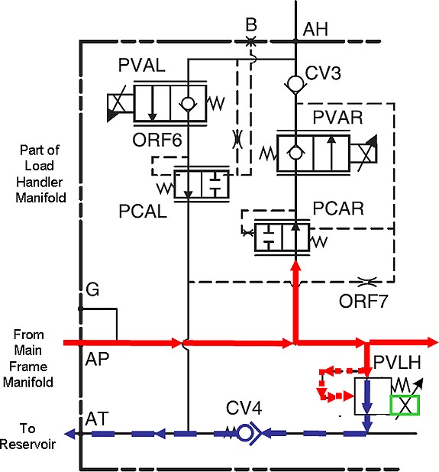With no oil pressure or electrical energy applied, the bias spring will keep the valve of PVLH closed. However, the spring by itself will begin to compress when the oil pressure (on the other side of the PVLH valve) reaches approximately 100 PSI. Access 7 will, through Pulse Width Modulation, proportionally control the amount of current flow through the coil of PVLH. The amount of current flow is dependant upon which auxiliary function (or combination of functions) is operated. Current flow through the coil of PVLH creates a magnetic field that works to keep the valve of PVLH closed so that oil can flow to the function or functions being operated. When pilot oil flow (on the other side of the PVLH valve) reaches a pressure high enough to overcome the strength of the coil’s magnetic field, the PVLH valve will open and relieve oil flow to the hydraulic reservoir.

Hình 18

The purpose of the C2.1 PVLH Aux Relief calibration is to allow Access 7 to sense the amount of current flow required (through the PVLH coil) to allow the valve to oppose certain pressures. This will provide smooth operation of Auxiliary hydraulic functions during normal operation.

Pressing the **select** arrow key (when the display appears as it does in Figure 17) navigates into C2.1. If you are not depressing at least one of the three Operator Presence Pedals in the floor of the platform the display will show the message seen in Figure 19.

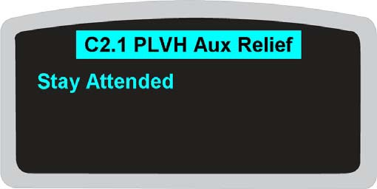

Hình 19

Tham khảo Hình 20. If you are depressing at least one of the Operator Presence Pedals the displayed message directs you to connect a pressure gauge and then press Enter (the **select** arrow key).

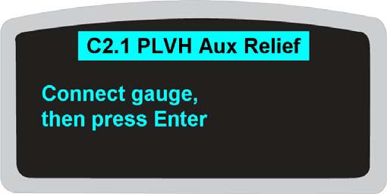

Hình 20

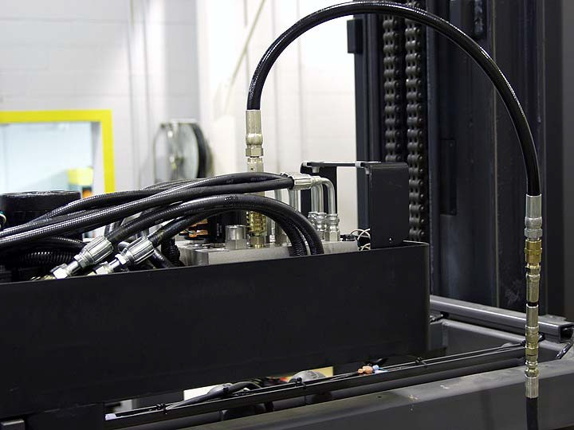Tham khảo Hình 21. A male quick disconnect fitting installed in the manifold block (marked G in Figure 18) in the top of the Load Handler is where the gauge is connected (1).

#### 1

Hình 21

Tham khảo Hình 22. With the Auxiliary mast (Load Handler) in the home position on the left hand side of the truck, the hose for the gauge (1) can be routed into the platform.

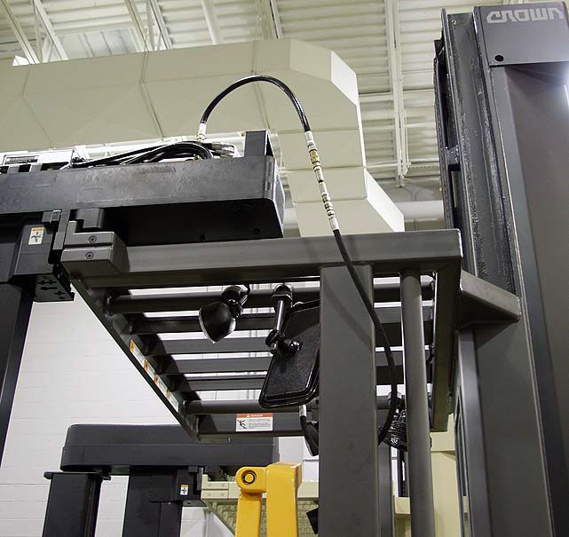

**1**

Hình 22

THẬN TRỌNG

The Auxiliary mast will not move during C2.1 PVLH Aux Relief calibration but it **will move** if Traverse is operated when the message on Access 1 display appears as it does in Figure 17. Do **NOT** attempt to traverse the Load Handler across the truck with the gauge connected to the Auxiliary hydraulic manifold.

Tham khảo Hình 23. With the face of the gauge placed so that you can read it from the operator’s position, press Enter (the **select** arrow key) on Access 1.

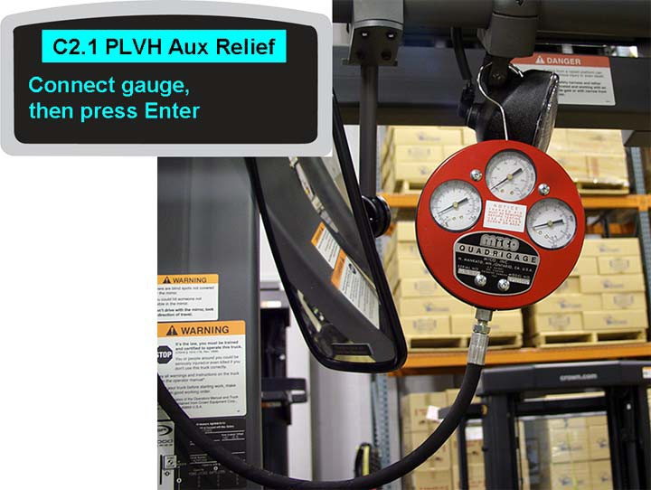

**1**

Hình 23

If you are using a Quadrigage for pressure readings, refer to the center gauge (1).

Again, if you are not pressing on at least one of the three Operator Presence Pedals the display will show the message seen in Figure 19.

Tham khảo Hình 24. The pump motor will begin to run and pressure will start to build. The message on Access 1 display will tell you to press Enter (the **select** arrow key) when the pressure on the gauge is at 700 PSI.

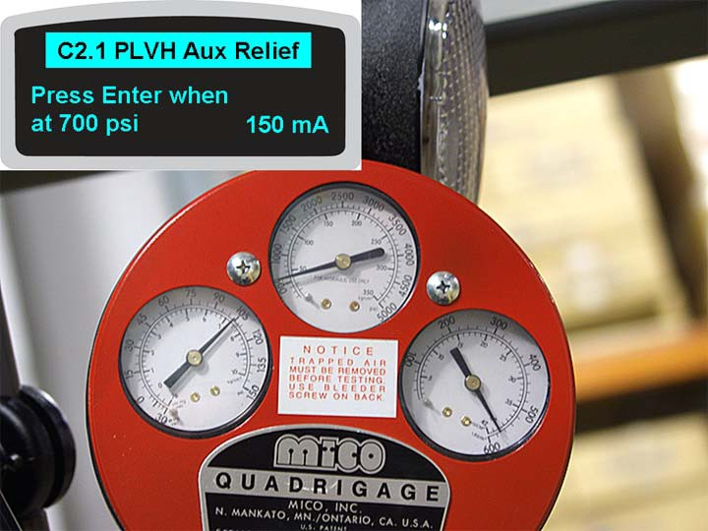

**1**

Hình 24

As the pressure on the gauge increases towards 700 PSI, the amount of current (in milliamps) (1) flowing through the coil of PVLH also increases.

You must maintain (keep depressed) at least one Operator Presence Pedal during the entire C2.1 PVLH Aux Relief calibration. After approximately three seconds with no input (no pedal pressed) the pump motor will stop and the display will again show the message seen in Figure 19. Once at least one of the pedals is depressed the calibration will continue.

Tham khảo Hình 25. After pressing Enter (the **select** arrow key) at 700 PSI, the displayed message will change and you are now prompted to press Enter when the gauge reads 1700 PSI.

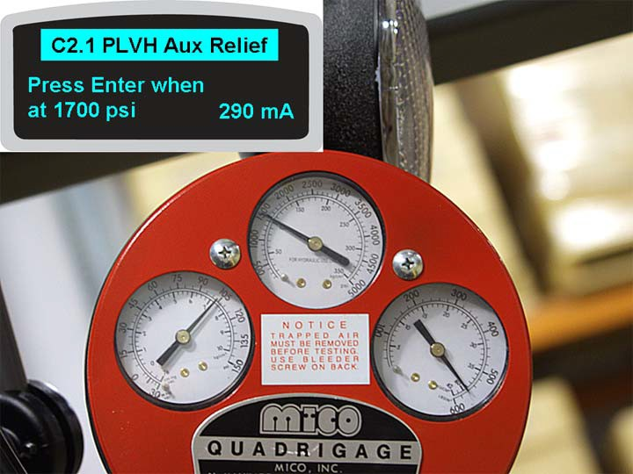

Hình 25

As the pressure on the gauge increases towards 1700 PSI, the amount of current (in milliamps) flowing through the coil of PVLH also increases.

Tham khảo Hình 26. After pressing Enter (the **select** arrow key) at 1700 PSI, the displayed message will change and you are now prompted to press Enter when the gauge reads 3500 PSI.

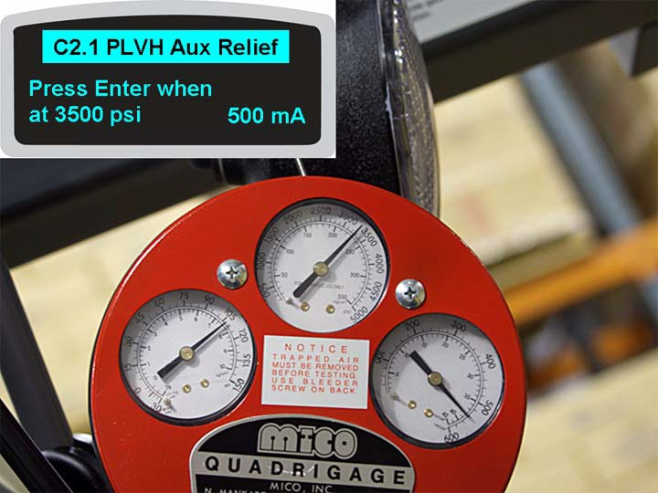

Hình 26

As the pressure on the gauge increases towards 3500 PSI, the amount of current (in milliamps) flowing through the coil of PVLH also increases.

Tham khảo Hình 27. After pressing Enter (the **select** arrow key) at 3500 PSI the system will compare the current values received during this calibration with programmed values. If those values are within specifications this message will be briefly displayed, then the display will revert to the message shown in Figure 17.

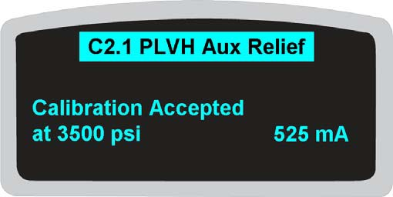

Hình 27

If the displayed message says **Calibration Failed** you will need to repeat the entire calibration or diagnose why C2.1 PVLH Aux Relief calibration cannot be performed.

**(LƯU Ý:** Disconnect pressure gauge from Auxiliary Hydraulic Manifold before proceeding.

Tham khảo Hình 28. Pressing the **next** arrow key when Access 1 is displaying the message shown in Figure 17 will navigate to C2.2 Traverse Sense.

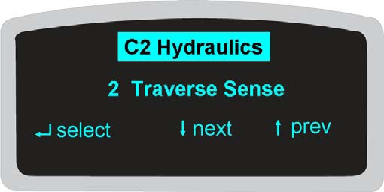

Hình 28

This Calibration allows the Access 123 system to sense the Traverse Position Encoder (ECR4) counts in each direction of travel, and determine what the encoder count value is at full traverse left and full traverse right.

Pressing the **select** arrow key navigates into C2.2 where you follow displayed instructions.

The first instruction is **Traverse Fully Right** then press the **select** arrow key. With your hands fully on both control handles use your right thumb to rotate the Traverse control towards you and hold that command until the Load Handler traverses fully to the right hand side of the truck, then press the **select** arrow key.

The second instruction is **Traverse Fully Left** then press the **select** arrow key. With your hands fully on both control handles use your right thumb to rotate the Traverse control away from you and hold that command until the Load Handler traverses fully to the left hand side of the truck, then press the **select** arrow key.

The third instruction is a repeat of the first. With your hands fully on both control handles use your right thumb to rotate the Traverse control towards you and hold that command until the Load Handler traverses fully to the right hand side of the truck, then press the **select** arrow key.

The display will also show ECR4 counts as you follow the instructions. These encoder counts will be negative when the Load Handler is to the left of platform center. As the Load Handler moves to the right, the magnetic proximity Traverse Reset Switch (TVRS) senses the small weldment on the center of the overhead guard. When that occurs, the displayed encoder counts will be positive.

After performing the third displayed step the system will compare ECR4 counts and the Traverse Reset point with programmed values and Access 1 will briefly display **Calibration Accepted** if values are within parameters. The display will then revert to the message shown in Figure 28. If Features, F6 Traverse Frame Width is not set correctly, the displayed message may read **Failed, Invalid Range**.

Tham khảo Hình 29. With C2.2 Traverse Sense correctly performed and the display as shown in Figure 28, pressing the **next** arrow key will navigate to C2.3 Pivot Sense.

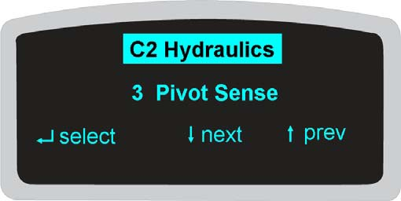

Hình 29

This calibration allows the Access 123 system to sense the voltage across the Pivot Position Sense potentiometer (POT5) when the fork carriage is pivoted fully right and fully left. These voltage values will be used by the system to determine when to display the message **Pivot Not Home** and slow truck travel when pivoting the fork carriage.

Pressing the **select** arrow key navigates into C2.3 where you follow displayed instructions.

The first instruction is **Pivot Fully Left** then press the **select** arrow key. With your hands fully on both control handles use your left thumb to rotate the Pivot control to cause the fork carriage to pivot fully home to the left of the Auxiliary Mast then press the **select** arrow key.

The second instruction is **Pivot Fully Right** then press the **select** arrow key. With your hands fully on both control handles use your left thumb to rotate the Pivot control to cause the fork carriage to pivot fully home to the right of the Auxiliary Mast then press the **select** arrow key.

The display will also show POT5 voltage as you perform the two steps.

After correctly performing the two steps Access 1 will briefly display the message **Calibration Accepted** then revert to the message shown in Figure 29.

Tham khảo Hình 30. With the display as shown in Figure 29, pressing the **next** arrow key will navigate to C2.4 Main Hgt Sense.

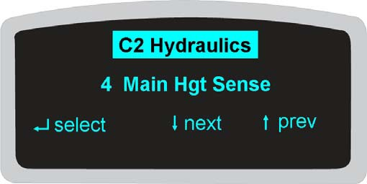

Hình 30

Performing this calibration establishes a maximum main lift height. This calibration allows the Access 123 system to “learn” Main Height Encoder (ECR5) counts at that maximum main lift height and also at full main lower. Also sensed is where (what encoder counts) the Main Height Reset Switch (HGTRS1) actuates.

Pressing the **select** arrow key navigates into C2.4 where you follow displayed instructions.

The first displayed instruction you might see is **Lower Below Reset**. You will only see this instruction if you start this calibration above the actuation point of Main Height Reset Switch (HGTRS1). Operate Main Lower to bring the platform below the actuation point of HGTRS1. As soon as that switch resets the display will automatically change to the next instruction.

**Raise Above Reset**. If you start calibration when the platform is fully lowered, this will be the first instruction displayed. ECR5 counts will be shown on the right side of the display. These counts will be a negative value below the actuation point of HGTRS1. Operate Main Raise. Shortly after HGTRS1 actuates (ECR5 counts change to a positive value) the displayed message will change to the next instruction.

**Lower to Min Height**, then press the **select** arrow key. Operate Main Lower until the platform is completely lowered then press then press the **select** arrow key. The displayed message will change to the next instruction.

**Raise to Max**, then press the **select** arrow key.

This portion of the calibration establishes the maximum height the platform and mast will rise to when operating Main Raise. Operate Main Raise to the height where you want the maximum limit to be established, come to a stop and press the **select** arrow key. Be sure to watch for any obstructions. After a certain height, the top of the Load Handler will be the highest point on the truck.

When you have successfully finished, Access 1 will briefly display **Calibration Accepted** then revert to the message displayed in Figure 30.

(LƯU Ý: **C2.99 Save Hydr Cal** must be performed before the Max Height value takes effect. Once C2.4 Main Hgt Sense is saved, Main Raise will automatically slow just before reaching the calibrated max height and stop 25 mm (1 in) less than the calibrated max height.

Tham khảo Hình 31. With the display as shown in Figure 30, pressing the **next** arrow key will navigate to C2.5 Main R Valve. This calibration allows the Access 123 system to sense the Breakout point for Main Raise and the amount of current flow through Proportional Valve Main Raise (PVMR) necessary to achieve five predetermined lift speeds.

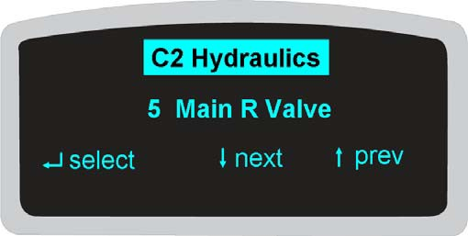

Hình 31

The Breakout point referenced here is the point where PVMR has opened far enough to allow enough oil flow to achieve mechanical movement. Mechanical movement is sensed through ECR5 counts.

Pressing the **select** arrow key navigates into C2.5 where you follow displayed instructions. Along with those instructions the display will show either current flow through the coil of PVMR or the main mast height.

**Lower To Min, Raise To Begin** is the first instruction displayed. Operate Main Raise fully. As soon as you operate Main Raise the displayed message will change to the next instruction.

**Finding Breakout, Maintain**. Hold Main Raise at full command. The pump motor will begin running and current flow through PVMR will slowly increase. As soon as the breakout point is found the platform will begin to raise and the displayed message will change to the next instruction.

**Finding Speed 1 (or 2 – 5), Maintain**. Hold Main Raise at full command. As current flow through PVMR increases, Main Raise will operate faster. The displayed speed will increment as the system “finds” it.

**Paused – Lower, Raise To Cont**. If Max Height is reached before the system “finds” all five speeds, this message prompts you to operate Main Lower to get below that point then operate Main Raise again to continue the calibration. The system will pick up where it left off.

NOTE: full mast extension or full lower is not required.

**Stop Command**. Once all five speeds have been found the display will show this message and the platform/mast will stop. After you release the full main raise command Access 1 will briefly display **Calibration Accepted**, then revert to the message displayed in Figure 31.

Tham khảo Hình 32. With the display as shown in Figure 31, pressing the **next** arrow key will navigate to C2.6 Main L Valve. This calibration allows the Access 123 system to sense the Breakout point for Main Lower and the amount of current flow through Proportional Valve Main Lower (PVML) necessary to achieve six predetermined lower speeds.

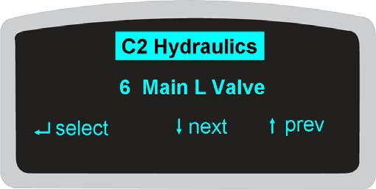

Hình 32

The Breakout point referenced here is the point where PVML has opened far enough to allow enough oil flow to achieve mechanical movement. Mechanical movement is sensed through ECR5 counts.

Pressing the **select** arrow key navigates into C2.6 where you follow displayed instructions. Along with those instructions the display will show either current flow through the coil of PVML or the main mast height.

**Raise To Max, Lower To Begin** is the first instruction displayed. Operate Main Raise to a convenient height or to Max Height (full mast extension or full lower is not required) then operate Main Lower fully. As soon as you operate Main Lower the displayed message will change to the next instruction.

**Finding Breakout, Maintain**. Hold Main Lower at full command. Current flow through PVML will slowly increase. As soon as the breakout point is found the platform will begin to lower and the displayed message will change to the next instruction.

**Finding Speed 1 (or 2 – 6), Maintain**. Hold Main Lower at full command. As current flow through PVML increases, Main Lower will operate faster. The displayed speed will increment as the system “finds” it.

The display will automatically advance each time a new speed is found.

**Paused – Raise, Lower To Cont**. If Max Lower is reached before the system “finds” all six speeds, this message prompts you to operate Main Raise to get above that point then operate Main Lower again to continue the calibration. The system will pick up where it left off.

**Stop Command**. Once all six speeds have been found the display will show this message and the platform/mast will stop. After you release the full main lower command Access 1 will briefly display **Calibration Accepted**, then revert to the message displayed in Figure 32.

Tham khảo Hình 33. With the display as shown in Figure 32, pressing the **next** arrow key will navigate to C2.7 Aux Flow Valve. This calibration allows the Access 123 system to sense how much current flow through Auxiliary Proportional Valve (SP1) is necessary to achieve the required oil flow for all auxiliary (Load Handler) hydraulic functions.

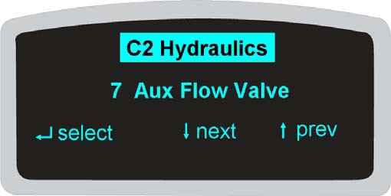

Hình 33

Pressing the **select** arrow key navigates into C2.7 where you follow displayed instructions. Along with those instructions the display will show either current flow through the coil of SP1 or fork carriage height.

The displayed instructions for this calibration basically mirror the instructions displayed during C2.5 Main R Valve calibration where the system found the breakout point and five speeds. The difference is you will be operating Auxiliary Raise instead of Main Raise.

THẬN TRỌNG

As the speeds increase the fork carriage will contact the stops with increasing force. Stopping the carriage just short of full auxiliary lift is recommended.

When this calibration is successfully completed Access 1 will briefly display **Calibration Accepted**, then revert to the message displayed in Figure 33.

Tham khảo Hình 34. With the display as shown in Figure 33, pressing the **next** arrow key will navigate to C2.8 Traverse Valve. This calibration allows the Access 123 system to sense how much current flow through each of the coils on Proportional Valve Traverse (PVT) is necessary to achieve traverse movement in each direction.

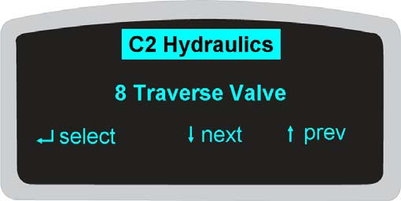

Hình 34

Pressing the **select** arrow key navigates into C2.8 where you follow displayed instructions. Along with those instructions the display will show current flow through either coil PVT1 or coil PVT2. (These coils are identified as S1/S2 in the hydraulic schematics.)

**Traverse Left or Rt to Begin** is the first instruction.

Operate full Traverse in one direction or the other. As soon as a Traverse command is detected the displayed message will change to the next instruction.

#### Maintain Command

Continue to hold full Traverse. Access 7 will slowly increase current flow through either coil PVT1 or coil PVT2 (S1 or S2) until movement in that direction is sensed (through feedback from ECR4) then Access 7 will repeat the process for the other coil.

**Stop Command**. When Access 1 displays this instruction, release the Traverse thumb ball. Access 1 will briefly display **Calibration Accepted**, then revert to the message displayed in Figure 34.

Tham khảo Hình 35. With the display as shown in Figure 34, pressing the **next** arrow key will navigate to C2.9 Pivot Valve. This calibration allows the Access 123 system to sense how much current flow through each of the coils on Proportional Valve Pivot (PVP) is necessary to achieve pivot movement in each direction. Pivot movement is sensed through changing voltage across POT5.

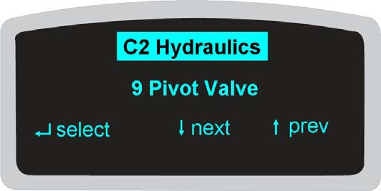

Hình 35

Pressing the **select** arrow key navigates into C2.9 where you follow displayed instructions. Along with those instructions the display will show current flow through either coil PVP1 or coil PVP2. (These coils are identified as S1/S2 in the hydraulic schematics.)

The displayed instructions for this calibration basically mirror the instructions displayed during C2.8 Traverse Valve calibration. The difference is you will be operating Pivot instead of Traverse.

When this calibration is successfully completed Access 1 will briefly display **Calibration Accepted**, then revert to the message displayed in Figure 35.

Tham khảo Hình 36. With the display as shown in Figure 35, pressing the **next** arrow key will navigate to C2.10 Extend Valve. This calibration allows the Access 123 system to sense how much current flow through each of the coils on Proportional Valve Fork Extend/Retract (PVF) is necessary to achieve fork movement in each direction. Fork movement is sensed by changing input from FHSL & FHSR.

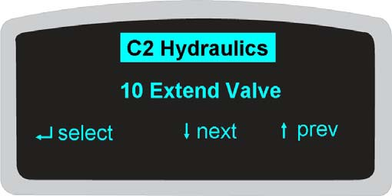

Hình 36

(LƯU Ý: Telescopic forks are an option. If Features F7 is not set to **Telescopic** this submenu description will be followed by **(n/a)** and you will not perform this calibration.

Pressing the **select** arrow key navigates into C2.10 where you follow displayed instructions. Along with those instructions the display will show current flow through either coil PVF1 or coil PVF2. (These coils are identified as S1/S2 in the hydraulic schematics.)

The displayed instructions for this calibration mirror the instructions displayed during C2.8 Traverse Valve calibration. The difference is Fork Extend/Retract will occur instead of Traverse.

When this calibration is successfully completed Access 1 will briefly display **Calibration Accepted**, then revert to the message displayed in Figure 36.

Tham khảo Hình 37. With the display as shown in Figure 36, pressing the **next** arrow key will navigate to C2.11 Aux R Valve. This calibration allows the Access 123 system to sense the Breakout point for Auxiliary Raise and the amount of current flow through Proportional Valve Auxiliary Raise (PVAR) necessary to achieve five predetermined lift speeds.

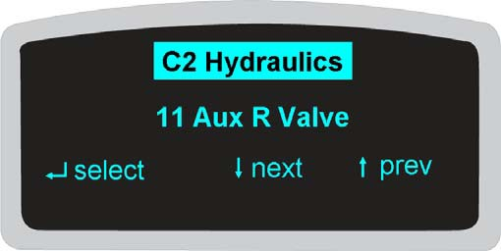

Hình 37

Pressing the **select** arrow key navigates into C2.11 where you follow displayed instructions. Along with those instructions the display will show either current flow through the coil of PVAR or fork carriage height.

The displayed instructions for this calibration basically mirror the instructions displayed during C2.5 Main R Valve calibration where the system found the breakout point and five speeds. The difference is you will be operating Auxiliary Raise instead of Main Raise.

THẬN TRỌNG

As the speeds increase the fork carriage will contact the stops with increasing force. Stopping the carriage just short of full auxiliary lift is recommended.

When this calibration is successfully completed Access 1 will briefly display **Calibration Accepted**, then revert to the message displayed in Figure 37.

Tham khảo Hình 38. With the display as shown in Figure 37, pressing the **next** arrow key will navigate to C2.12 Weight Sense. No weight is required for this calibration. This calibration allows the Access 123 system to sense the output (counts) from the Load Sense Pressure Transducer (LS) with no weight on the forks, establishing a “baseline” for accurate weight display.

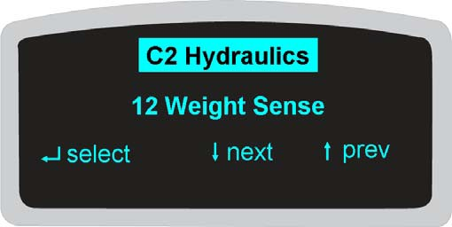

Hình 38

Pressing the **select** arrow key navigates into C2.12 where you follow displayed instructions. Along with those instructions the display will show you the milliamps from LS or aux lift height.

**Empty & Lower Forks**, then press the **select** arrow key is the first instruction.

**Slowly Raise Aux** is the second instruction. Operate Auxiliary Raise while watching the display.

**Stop Aux Function** is the third instruction. Release the Auxiliary Raise Control.

**Wait to Stabilize** is the fourth instruction; simply maintain the foot pedals. After a few seconds, if the feedback from LS is acceptable the message on the display will briefly show **Calibration Accepted** then revert to the message shown in Figure 38.

Tham khảo Hình 39. With the display as shown in Figure 38, pressing the **next** arrow key will navigate to C2.13 Aux L Valve. You need 91 - 227 kg (200 - 500 lbs) on the forks for this calibration. This calibration allows the Access 123 system to sense the Breakout point for Auxiliary Lower and the amount of current flow through Proportional Valve Auxiliary Lower (PVAL) necessary to achieve six predetermined lower speeds.

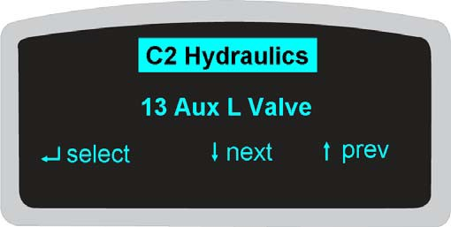

Hình 39

Pressing the **select** arrow key navigates into C2.13 where you follow displayed instructions. Along with those instructions the display will show either current flow through the coil of PVAL or fork carriage height.

The displayed instructions for this calibration basically mirror the instructions displayed during C2.6 Main L Valve calibration where the system found the breakout point and six speeds. The difference is you will be operating Auxiliary Lower instead of Main Lower.

When this calibration is successfully completed Access 1 will briefly display **Calibration Accepted**, then revert to the message displayed in Figure 39. At that point you can remove the weight from the forks before continuing.

Tham khảo Hình 40. With the display as shown in Figure 39, pressing the **next** arrow key will navigate to C2.14 Aux Height Sense. This calibration allows the Access 123 system to “learn” Auxiliary Height Encoder (ECR3) counts at maximum auxiliary lift height and full auxiliary lower. Also sensed is where (what encoder counts) the Auxiliary Height Reset Switch (HGTRS2) actuates.

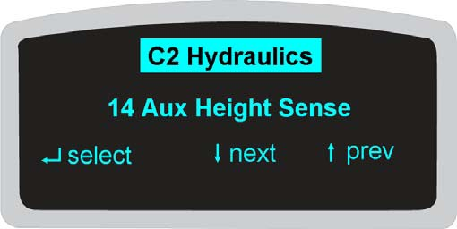

Hình 40

Pressing the **select** arrow key navigates into C2.14 where you follow displayed instructions. Along with those instructions the display will show ECR3 counts.

The first displayed instruction you might see is **Lower Below Reset**. You will only see this instruction if you start this calibration above the actuation point of Auxiliary Height Reset Switch (HGTRS2). Operate Auxiliary Lower to bring the fork carriage below the actuation point of HGTRS2. As soon as that switch resets the display will automatically change to the next instruction.

**Raise Above Reset**. If you start calibration when the fork carriage is fully lowered, this will be the first instruction displayed. ECR3 counts will be shown on the right side of the display. These counts will be a negative value below the actuation point of HGTRS2. Operate Auxiliary Raise. Shortly after HGTRS2 actuates (ECR3 counts change to a positive value) the displayed message will change to the next instruction.

**Lower to Min Height**, then press the **select** arrow key. Operate Auxiliary Lower until the fork carriage is completely lowered then press the **select** arrow key. When this calibration is successfully completed Access 1 will briefly display **Calibration Accepted**, then revert to the message displayed in Figure 40.

Tham khảo Hình 41. Two other C2 calibration menus are available for trucks equipped for tilting forks or a fork positioner. Conducting these calibrations is done by following displayed directions.

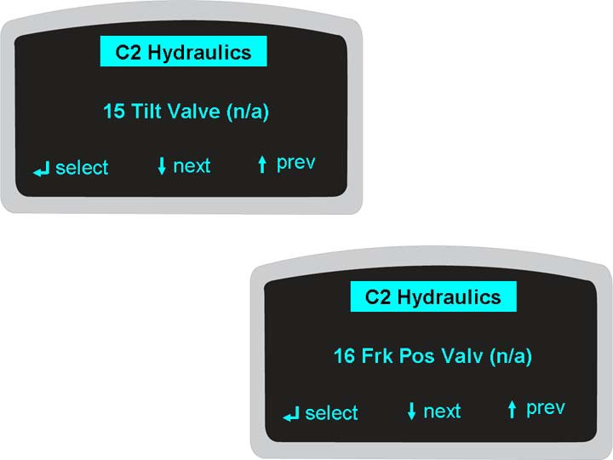

Hình 41

(LƯU Ý: If Features F7 is not set to **Tilting Fork** C2.15 Tilt Valve will be followed by **(n/a)**. Likewise, C2.16 Frk Pos Valv will be followed by **(n/a)** if Features F7 is not set to **Fork Position**.

Tham khảo Hình 42. Pressing the **next** arrow key when C2.16 Frk Pos Valv is displayed will navigate to C2.99 Save Hydr cal. If you do not save the previous calibrations, the system will revert to previously stored values for all of the hydraulic functions.

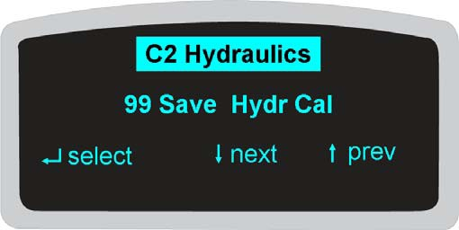

Hình 42

Tham khảo Hình 43. Nhấn phím mũi tên chọn để điều hướng tới C2.99. Tại đây, lựa chọn đầu tiên, 1 Không lưu sẽ được bôi đậm. Nhấn phím mũi tên tiếp tục để chuyển phần bôi đậm xuống 2, Có, Lưu các giá trị và lại nhấn thêm một lần nữa để chuyển phần tô đậm xuống 3, Tải các giá trị mặc định.

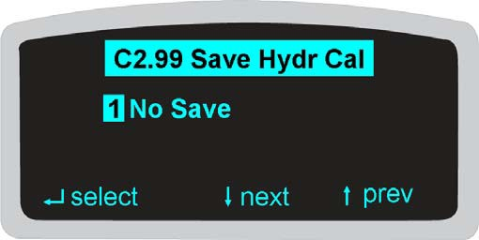

Hình 43

Sử dụng các phím mũi tên **tiếp tục** hoặc **quay lại** để bôi đậm lựa chọn bạn muốn chọn và nhấn phím mũi tên **chọn**. Hệ thống sẽ thực hiện chức năng bạn ra lệnh cho nó thực hiện và Màn hình Truy cập 1 sẽ trở lại tin nhắn đượ thể hiện trong Hình 16.

#### C2 Hydraulics Questions

Ask your instructor for a TSP6000 and a service manual for that truck. In a “test area” ***away from obstructions and pedestrian or truck traffic*** access Level 2 – Field Service Mode and navigate to Calibration/C2 Hydraulics. Perform the calibrations listed and fill in the requested information on the line provided below. When you’ve finished, SAVE all calibrations, navigate out of C2, and turn the truck OFF. Compare your answers with those found on the page before the skill check. Hỏi người hướng dẫn bất cứ câu hỏi nào nếu muốn.

#### C2.1 PVLH Aux Relief

Where is the pressure gauge connected? What three pressures did you have to watch for?

#### C2.2 Traverse Sense

Which encoder is being monitored during this calibration? How many times did you have to traverse right?

How many times did you have to traverse left?

#### C2.3 Pivot Sense

Which potentiometer is being monitored during this calibration?

#### C2.4 Main Hgt Sense

Which encoder is being monitored during this calibration? Which switch is being monitored during this calibration?

Does this calibration (when saved) establish a maximum main lift height?

#### C2.5 Main R Valve

Which valve is being monitored for a Breakout point during this calibration? How many Raise speeds were found during this calibration?

#### C2.6 Main L Valve

Which valve is being monitored for a Breakout point during this calibration? How many Lower speeds were found during this calibration?

#### C2.7 Aux Flow Valve

Which valve is being monitored for a Breakout point during this calibration? How many speeds were found during this calibration?

Were they Raise speeds or Lower speeds?

#### C2.8 Traverse Valve

Which valve is being monitored during this calibration?

During Maintain Command, how is Traverse movement sensed?

#### C2.9 Pivot Valve

Which valve is being monitored during this calibration?

How is Pivot movement sensed?

#### C2.10 Extend Valve

The truck must be equipped with forks and Features Menu has to be set to

in order to perform this calibration.

What components provide indication of fork movement?

#### C2 Hydraulics Questions (cont.)

**C2.11 Aux R Valve**

Which valve is being monitored for a Breakout point during this calibration? How many Raise speeds were found during this calibration?

#### C2.12 Weight Sense

How much weight is needed for this calibration?

#### C2.13 Aux L Valve

How much weight is needed for this calibration?

Which valve is being monitored for a Breakout point during this calibration? How many Lower speeds were found during this calibration?

#### C2.14 Aux Height Sense

Which encoder is being monitored during this calibration? Which switch is being monitored during this calibration?

#### C3 Height Cutouts

Tham khảo Hình 44. Pressing the **next** arrow key when Access 1 is displaying the message shown in Figure 16 will navigate to the C3 Height Cutouts menu. This menu allows you to program up to six cutouts into main mast raise or lower.

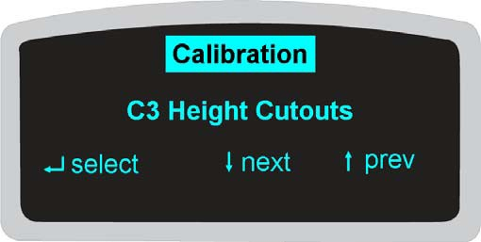

Hình 44

Tham khảo Hình 45. Pressing the **select** arrow key navigates into C3 where C3.1, the first of the six programmable cutouts, is displayed.

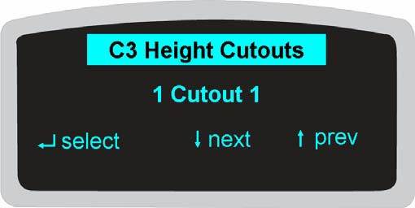

Hình 45

Tham khảo Hình 46. Pressing the **select** arrow key again, navigates into C3.1 where you are prompted to position main raise or lower to the height you wish to install a cutout, then press the select arrow key to **set** that height.

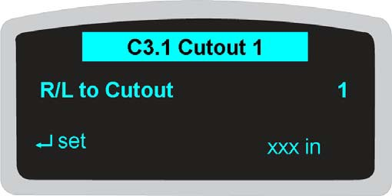

Hình 46

(LƯU Ý: Height will be shown in inches (in) if Features F3 is set to English, and millimeters (mm) if F3 is set to Metric.

Tham khảo Hình 47. The next displayed message is where you choose what **type** of cutout you want set. The first choice is highlighted and you can **change** that choice by using the **up/down** arrow keys.

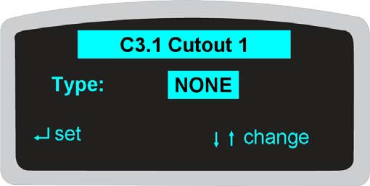

Hình 47

Choices available are:

**NONE** – no cutout.

**PCT** – this stands for Positive Cutout. A stop will occur during main raise (positive) but (since it is a cutout) by holding the Override button (on the left hand control) depressed and operating main raise again you can continue on to the next cutout or Max Height if no other cutouts have been programmed.

**PST** – this stands for Positive Stop. A stop will occur during main raise (positive) and (since it is a stop) you cannot continue any higher.

**NCT** - this stands for Negative Cutout. A stop will occur during main lower (negative) but (since it is a cutout) by holding the Override button (on the left hand control) depressed and operating main lower again you can continue on to the next cutout or lower completely if no other cutouts have been programmed.

Tham khảo Hình 48. With the type of cutout you want highlighted, pressing the **set** arrow key navigates to another submenu. This is where you decide when you want the cutout to affect main raise/lower. The choices, which are selected by using the **up/down** arrow keys to highlight and the **set** arrow key to choose, are **Always** or **FR Only**. **Always** means the cutout will affect the truck regardless of where it’s being operated. **FR** stands for **Free Ranging** and means the truck is being operated outside of a guided aisle.

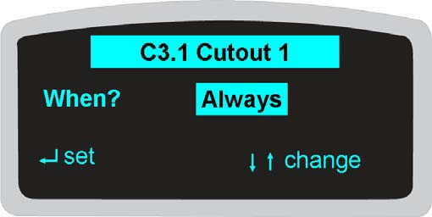

Hình 48

Highlighting your choice and pressing the **set** arrow key will navigate out to a display similar to Figure 45 except 2 Cutout 2 is the second line of information.

Tham khảo Hình 49. An exception to the previous sentence would occur if Features F29 Zone Switch is set to **Yes**. Under that condition, the next displayed message will ask in what Zone the cutout should be effective.

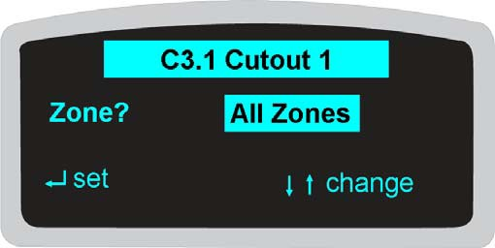

Hình 49

Choices available are:

**All Zones** – the cutout is effective regardless of ZSS position. **Zone A** – the cutout will only occur if ZSS is set to the A position. **Zone B** – the cutout will only occur if ZSS is set to the B position. **Zone C** – the cutout will only occur if ZSS is set to the C position.

Highlighting your choice and pressing the **set** arrow key will navigate out to a display similar to Figure 45 except 2 Cutout 2 is the second line of information.

Cutouts 2 through 6 are set in the same manner as previously discussed.

Tham khảo Hình 50. C3.7 is where you navigate to when you are ready to save your programmed cutouts.

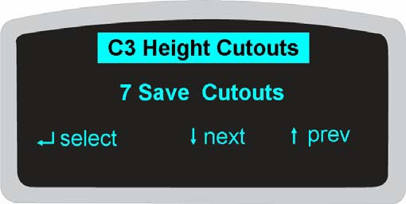

Hình 50

Tham khảo Hình 51. Nhấn phím mũi tên chọn để điều hướng tới C3.7. Tại đây, lựa chọn đầu tiên, 1 Không lưu sẽ được bôi đậm. Pressing the **next** arrow key moves the highlight down to 2 Yes, Save Values and pressing it again moves the highlight down to 3 Clear All. Choosing 3 will cause the system to erase **all** previously programmed cutouts.

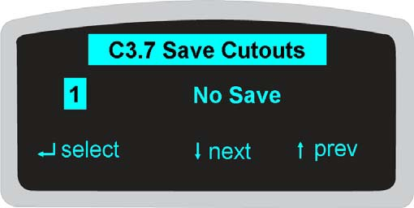

Hình 51

Sử dụng các phím mũi tên **tiếp tục** hoặc **quay lại** để bôi đậm lựa chọn bạn muốn chọn và nhấn phím mũi tên **chọn**.

Tham khảo Hình 52. If you highlighted 2 Yes, Save Values and pressed Select, this message tells you Save is being performed. Do not operate any function during this process and after a few seconds Access 1 will revert to the message displayed in Figure 44.

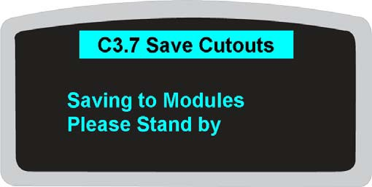

Hình 52

#### C3 Height Cutouts Questions

Ask your instructor for a TSP6000 and a service manual for that truck. In a “test area” ***away from obstructions and pedestrian or truck traffic*** access Level 2 – Field Service Mode and navigate to Calibration/C3 Height Cutouts.

Answer the following questions and compare your answers with those found on the page before the skill check. Hỏi người hướng dẫn bất cứ câu hỏi nào nếu muốn.

1. What is the total number of Height Cutouts that can be programmed?
2. You are programming Cutout 1. What choices are available for Type?
3. What is the difference between a PCT and an NCT?
4. If you select PST for a Type for Cutout 1 (and Save it) can you install a Cutout 2 above (higher than) Cutout 1?
5. What is the difference between Always and FR Only?

#### C4 Steer Encoder

This calibration ensures that when the truck’s steering is at mechanical center, the Index channel in ECR6, the Steering Feedback Encoder is outputting a high, or +5V to Access 5. This is important for correct steering operation especially in a guided aisle. If ECR6 is not correctly aligned, the power unit end of the truck may weave excessively, the truck may not guide properly, and the steering position indicators on Access 1 will not be as accurate as possible.

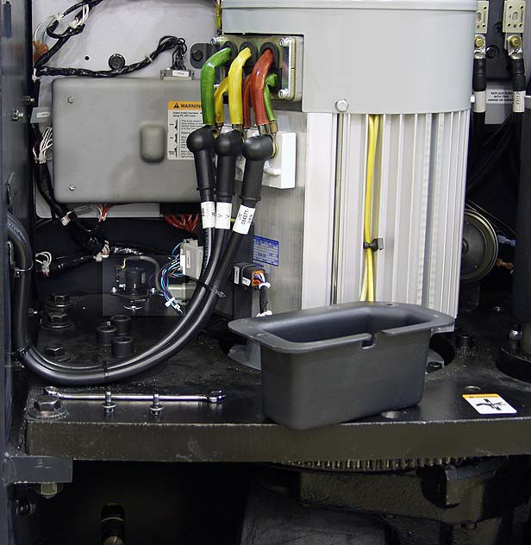Tham khảo Hình 53. Before proceeding you will need to make a few preparations. With the truck OFF, (powered down), use a 10mm wrench to remove the cover from ECR6 (1).

1

Hình 53

Tham khảo Hình 54. Power the truck up in Service Level 2 and navigate to Calibration/C4 Steer Encoder.

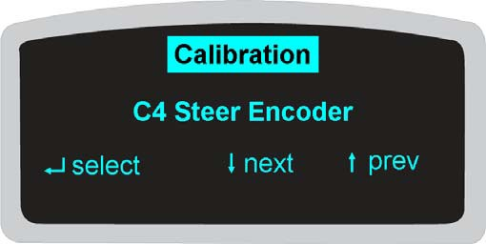

Hình 54

Next, position the Guidance Select Switch (GUS) (located on the right hand arm rest) so that Manual Steering is active.

Tham khảo Hình 55. Using Manual Steering, position the steer tire to the straight ahead position so that the hole in the drive unit mounting plate is aligned with the hole in the steering ring gear. With those two holes aligned, a ½” or 12 mm diameter pin (1) can be inserted through the two holes, locking steering at mechanical center.

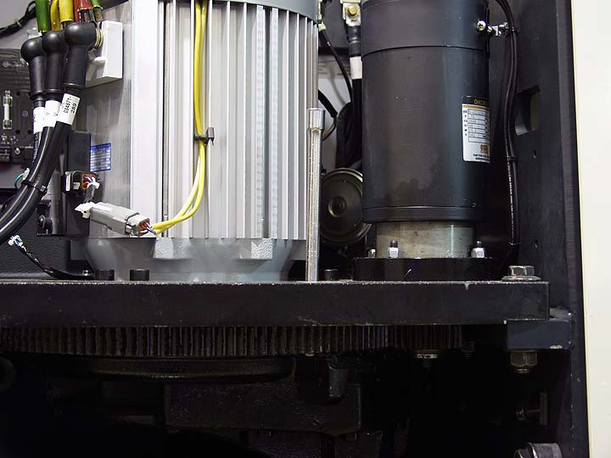

1

Hình 55

NOTE: a 3/8” extension can be used for this purpose.

Now pressing the **select** arrow key when Access 1 is displaying the message shown in Figure 54 will navigate into C4 Steer Encoder. Steering will be inactive at this point.

Tham khảo Hình 56. If ECR6 is already “at Index” the truck’s status alarm will sound a steady tone and Access 1 will display this message.

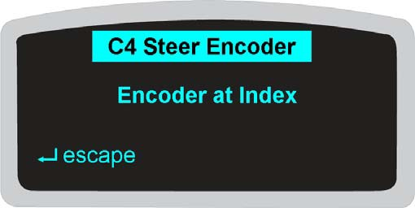

Hình 56

Pressing the **escape** arrow key will return the display to what is shown in Figure 54.

Tham khảo Hình 57. If ECR6 is “off Index” one way or the other the truck’s status alarm will beep periodically and Access 1 will display a message either telling you to index the encoder or telling you how far from index the encoder is.

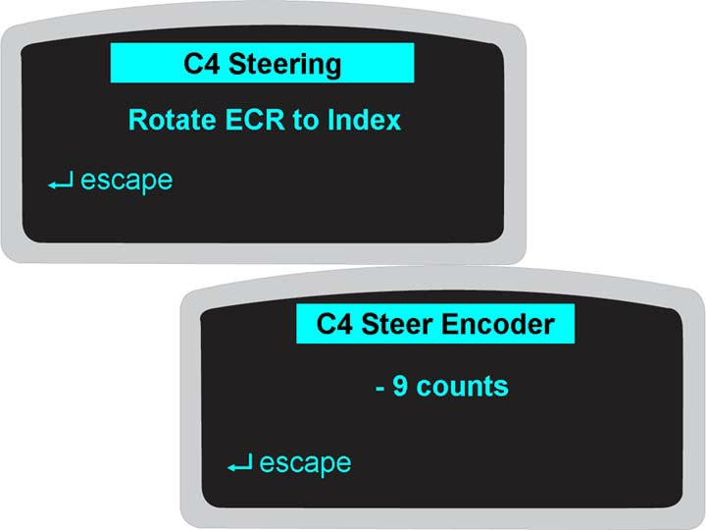

Hình 57

(LƯU Ý: The first message shown in Figure 57 will most probably be displayed if you enter into C4 before “pinning” steering at mechanical center.

Tham khảo Hình 58. To adjust ECR6, slightly loosen the screw on each side of the encoder (1) then slowly rotate the body of the encoder left or right.

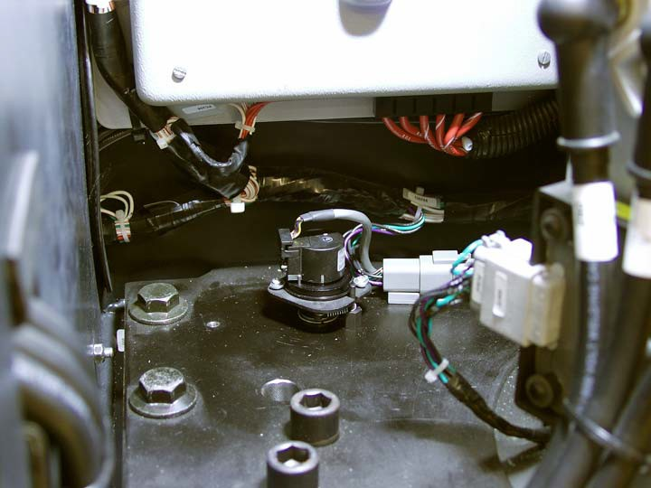

1

Hình 58

As the encoder gets closer to Index, the status alarm will beep more frequently and when ECR6 is at Index the alarm will emit a steady tone and the displayed message will appear as in Figure 56. Carefully tighten the two screws (firmly but do not over-tighten) while making sure the alarm still emits a steady tone.

If, when turning the encoder, the status alarm beeps less frequently or stops beeping altogether you know you turned the encoder in the wrong direction.

With ECR6 at Index and Access 1 displaying the message shown in Figure 56, press the **escape** arrow key. Manual steering will be active again and you should be able to pull the pin that is locking steering at center.

If the pin won’t come out, stand off of the truck and recycle KYS. After Access 123 system “boot up”, use your hand to press on one of the Operator Presence Pedals then quickly get to the back of the truck and remove the pin as the steering goes through self test.

Reinstall the cover for ECR6.

#### C4 Steer Encoder Questions

Ask your instructor for a TSP6000 and a service manual for that truck. In a “test area” ***away from obstructions and pedestrian or truck traffic*** access Level 2 – Field Service Mode and navigate to Calibration/C4 Steer Encoder.

Answer the following questions and compare your answers with those found on the page before the skill check. Hỏi người hướng dẫn bất cứ câu hỏi nào nếu muốn.

1. Which encoder is adjusted during this calibration?
2. Should GUS be set for Manual or Auto?
3. What must be done to the steering before proceeding with C4 cal?
4. The status alarm is “beeping” every few seconds and the displayed message says -20 counts. What must you do?
5. What does it mean if, during your performance to answer question #4, the status alarm “beeps” even less often?

#### C5 Wire Guidance

The TSP6000 service manual, pages M4.3-1960-500 through 504, contains general information on Wire Guidance as well as specific information such as adjusting sensor bar height, checking Line Driver output (Field Strength), and performing wire guidance calibration in a guided aisle with the highest average field strength. Read/review this section of the service manual before proceeding with Wire Guidance Calibration.

Wire Guidance calibration is required for optimal performance when operating a truck inside a guided aisle. This procedure should be performed whenever any of the following components are replaced:

Access 5 (Steering Control Module) Access 6 (Guidance Control Module) Steered wheel sensor bar (GS1) Load wheel sensor bar (GS2)

Steer motor (M3)

Steering feedback encoder (ECR6)

Calibration should also be performed if either sensor bar or ECR6 is adjusted.

Tham khảo Hình 59. Pressing the **next** arrow key when Access 1 is displaying the message shown in Figure 54 will navigate to the C5 Wire Guide menu.

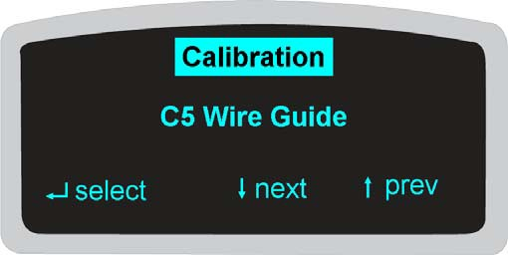

Hình 59

Tham khảo Hình 60. Pressing the **select** arrow key will navigate into C5 Wire Guide and display the first submenu. Two other submenus at this level (displayed by using the **next** arrow key) are C5.2 Adjust X-Offset, and C5.99 Save Guidance.

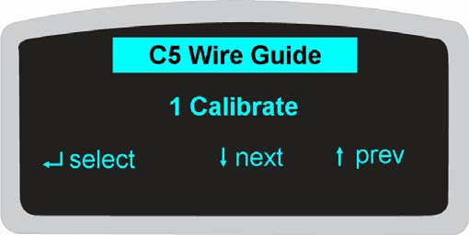

Hình 60

Tham khảo Hình 61. Pressing the **select** arrow key will navigate into C5.1 Calibrate where the first submenu is C5.1.1 Set Response. At this display you are prompted to set, from 1 to 9, how responsive or reactive steering will be to guidance sensor value change. 1 is the least responsive and 9 is the most responsive.

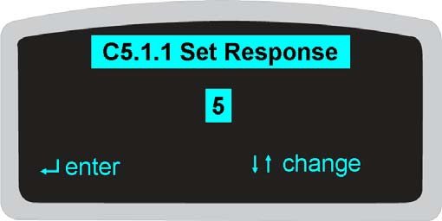

Hình 61

Tham khảo Hình 62. After entering the Response value, Access 1 navigates to C5.1.2 Sensor Coil. One of two messages will be displayed, depending on the position of the Guidance Select Switch (GUS) (located on the right hand arm rest). If GUS is in the Auto position the message will prompt you to switch to the Manual position. If GUS is in the Manual position (or after you switch GUS to Manual) the message will prompt you to go to Auto when done.

The question to ask is “When done with what?”

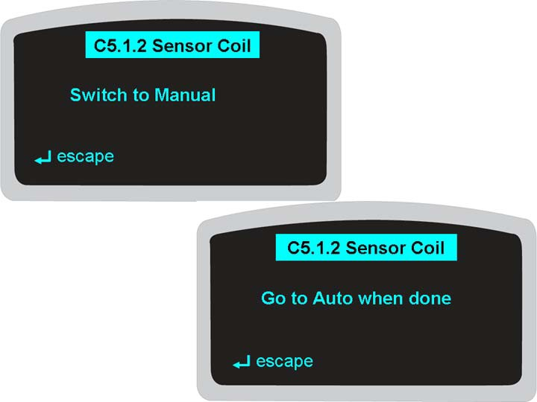

Hình 62

This calibration step is referred to in the service manual (M4.3-1960-504) as Peak Sensor Coil Search. There are four separate coils inside each sensor bar. During this calibration you will **slowly** drive the truck over an active guide wire at a shallow angle (five degrees or less) so that each coil (four in the platform end bar and four in the power unit end bar) passes directly over the wire at least two times. Perform this calibration step in a guided aisle with the highest average field strength.

Peak Sensor Coil Search determines the frequency of the floor signal, the amplitude of the floor signal, and the sensitivity of each of the eight individual coils. The amplitude value sensed by each individual coil is compared against the other coil values and the values of the weaker coils are “scaled” (multiplied by a given value) so that all eight coils appear equal.

When you are certain that each coil has passed over the guide wire twice, center the truck over that wire, come to a stop and switch GUS to Auto.

Tham khảo Hình 63. After switching GUS to Auto, Access 1 navigates to C5.1.3 Wheel Angle.

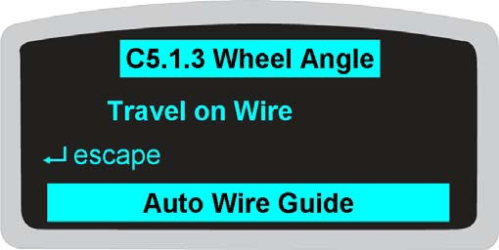

Hình 63

This calibration step is referred to in the service manual (M4.3-1960-504) as Steer Wheel Position Calibration. The system determines where the steered wheel has to be positioned in order to cause the truck to travel in a straight line.

The truck needs to travel a minimum of 18 m (60 ft) in both fork leading and fork trailing direction but it does not have to travel the full distance all at one time.

Tham khảo Hình 64. With GUS in the Auto position, start traveling in one direction or the other. Travel speed is limited and the Access 1 message will keep you informed regarding the progress of this calibration step.

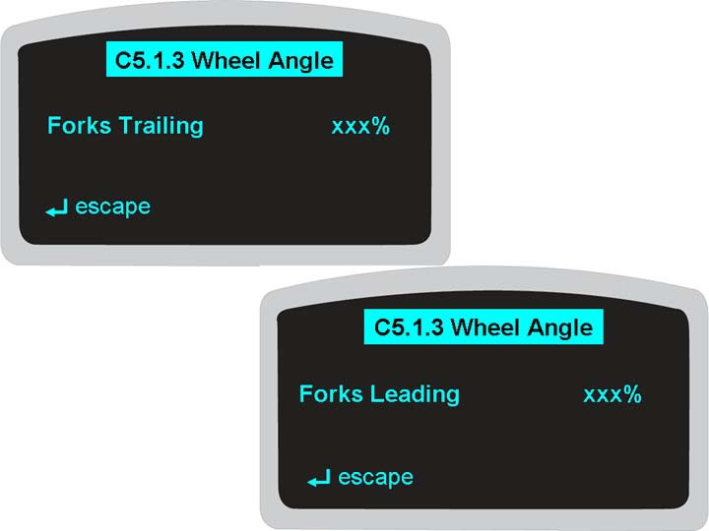

Hình 64

The displayed message shows what percentage of the current travel direction has been achieved.

Tham khảo Hình 65. When the truck has traveled the required 18m (60 ft) distance in one direction the status alarm will beep, the Access 1 message will show 100%, and you are instructed to change direction.

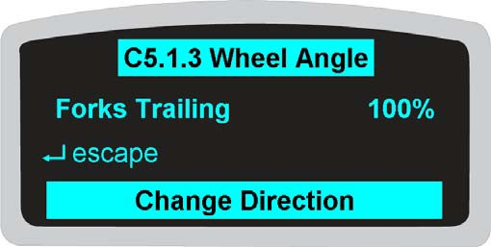

Hình 65

Tham khảo Hình 66. When the truck has traveled the required 18m (60 ft) distance in the other direction the status alarm will beep, the Access 1 message will show 100%, and you are instructed to stop the truck.



Hình 66

Tham khảo Hình 67. When the truck senses that it is not moving, the Access 1 message will instruct you to switch GUS to the Manual position. Doing so will (temporarily) save the Wheel Angle calibration. Immediately after you switch GUS, the Access 1 message will instruct you to switch GUS back to the Auto position.

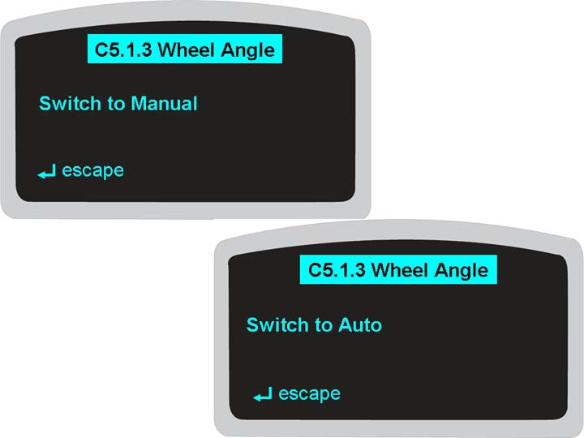

Hình 67

Tham khảo Hình 68. After switching GUS to Auto, Access 1 navigates to C5.1.4 Truck Angle.

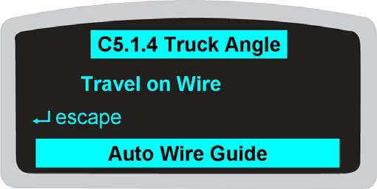

Hình 68

This calibration step is referred to in the service manual (M4.3-1960-504) as Truck Angle Calibration. The system compares feedback from the two sensor bars to determine if both ends of the truck are centered over the wire or if the truck is “dog-tracking” when traveling in either or both directions.

Just like C5.1.3, the truck needs to travel a minimum of 18 m (60 ft) in both fork leading and fork trailing directions and performing C5.1.4 calibration is virtually identical to what was done in C5.1.3.

When you have completed C5.1.4 Access 1 will revert to the message displayed in Figure 60. From there, pressing the **next** arrow key navigates to C5.2 Adjust X-Offset. This calibration is used to position the truck centerline over the guide wire but, it is only required if you know or suspect that the frame of the truck has been damaged. If you have no reason to suspect X-Offset needs to be performed, navigate down to C5.99 Save Guidance.

Before performing X-offset, you need to place a mark representing exact mechanical center of the truck on the platform end of the truck. This mark will be referenced to the wire in the floor during travel in both directions and needs to be visible from the operator’s position.

Tham khảo Hình 69. With Access 1 displaying this message, press the **select** arrow key.

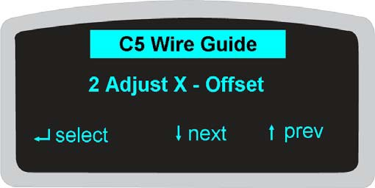

Hình 69

Tham khảo Hình 70. The next displayed message depends on the position of GUS.

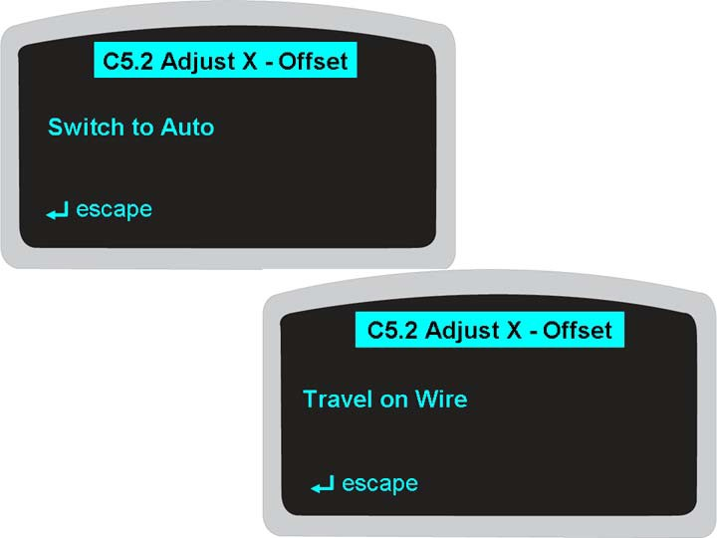

Hình 70

Tham khảo Hình 71. With GUS in the Auto position, start traveling in one direction or the other. The truck must travel at least 12 m (40 ft) and travel speed is NOT limited. The Access 1 message will keep you informed regarding the progress of this calibration step.

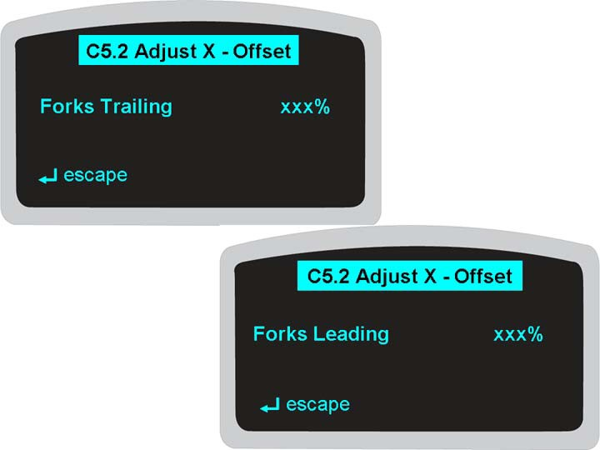

Hình 71

Travel at any speed while comparing the mark representing truck center to the wire in the floor. If it appears that the truck operates more (or always) to one side of the guide wire, offset adjustment may be needed.

Tham khảo Hình 72. When the truck has traveled the required distance in one direction the status alarm will beep, the Access 1 message will show 100% and **Distance Reached**. Bring the truck to a stop.

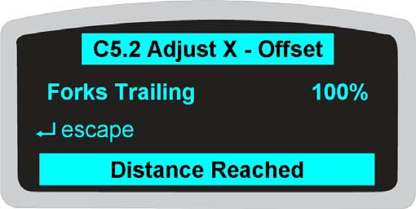

Hình 72

Tham khảo Hình 73. When the truck senses that it is no longer moving Access 1 will change the displayed message.

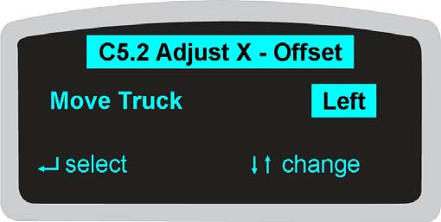

Hình 73

If, while traveling, it appeared that the truck was always operating to the right of the guide wire, press the **select** arrow key. If the truck was always to the left of the guide wire, use the **change** arrows to highlight **Right**, then press **select**.

#### (LƯU Ý: Left and Right are taken from the perspective of looking towards the power unit end of the truck. If, based on sitting in the seat and looking towards the forks, you offset the truck to your left, it will actually move to your right.

Tham khảo Hình 74. This Access 1 message allows you to set an offset distance, one digit at a time, by using the **change** and **enter** arrows. Offset will be shown in sixteenths of an inch if Features F3 is set to English, and millimeters (mm) if F3 is set to Metric. The maximum amount of offset that can be entered is 50 mm (32 sixteenths of an inch).

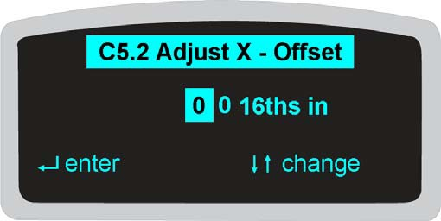

Hình 74

Tham khảo Hình 75. After entering the second digit of the offset value the displayed message changes and you are prompted to continue with X-Offset or exit.

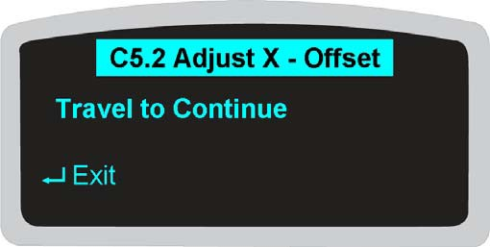

Hình 75

If you adjusted the offset in one direction of travel it is recommended to operate the truck in the other direction while comparing the mark representing truck center to the wire in the floor, and offsetting the truck by the amount necessary to center the truck over the guide wire in that direction of travel.

Pressing Exit will navigate out to the message shown in Figure 69. From there navigate down to C5.99 Save Guidance. The three choices inside that submenu are:

1. **No Save** – this choice causes the system to revert to previous calibration settings.
2. **Yes, Save Values** – this choice causes the system to save your calibration values.
3. **Load Defaults** – this choice cause the system to load factory default settings. These values may not match your specific application, particularly with regards to peak sensor coil values.

Highlight one of these choices and press the **select** arrow key. The system will perform whatever function you requested and Access 1 display will navigate to the message shown in Figure 59. From there press the **next** arrow key to navigate to C99 Escape then press the **select** arrow key to exit Calibration.

#### C5 Wire Guide Questions

Ask your instructor for a TSP6000 and a service manual for that truck. In a guided aisle with an active floor signal, access Level 2 – Field Service Mode and navigate to Calibration/C5 Wire Guide. Answer the following questions and compare your answers with those found on the page before the skill check. The answer to some of these questions can be found in the information contained on M4.3-1960-500 – 504. Hỏi người hướng dẫn bất cứ câu hỏi nào nếu muốn.

1. What is the maximum approach angle when aligning a TSP6000 to a wire guide signal?
2. At what height should the sensor bars be set?
3. Should the Line Driver Output be checked before proceeding with C5 cal?
4. What is the recommended Field Strength Value for a Line Driver operating at 6.25 Khz?
5. During C4 Steer Encoder calibration you had to adjust ECR6. Does this mean you should also perform C5 Wire Guide calibration?
6. What do you affect by changing C5.1.1 Set Response?
7. Access 1 is displaying C5.1.2 Sensor Coil Go to Auto when done. What are you supposed to do before switching GUS to Auto?
8. What does Peak Sensor Coil Search determine?
9. What is the total distance the truck must travel to complete C5.1.3 Wheel Angle Calibration?
10. Does C5.2 Adjust X-Offset calibration have to be performed?

#### Trả lời các câu hỏi trong phần C2 Các hệ thống thủy lực học

**C2.1 PVLH Aux Relief** Auxiliary Hydraulic Manifold. 700 PSI

1700 PSI

3500 PSI

#### C2.2 Traverse Sense

ECR4

Two One

#### C2.3 Pivot Sense

POT5

#### C2.4 Main Hgt Sense

ECR5 HGTRS1

Có

#### C2.5 Main R Valve

PVMR

Năm

#### C2.6 Main L Valve

PVML

Sáu

#### C2.7 Aux Flow Valve

SP1

Five Raise

#### C2.8 Traverse Valve

PVT

ECR4 counts

#### C2.9 Pivot Valve

PVP

POT5 voltage

#### C2.10 Extend Valve

Telescopic F7

Telescopic FHSL & FHSR

#### C2.11 Aux R Valve

PVAR

Năm

#### C2.12 Weight Sense

Không

#### C2.13 Aux L Valve

PVAL 91 - 227 kg (200 - 500 Ibs)

Sáu

#### C2.14 Aux Height Sense

ECR3 HGTRS2

#### Câu trả lời cho các câu hỏi về phần chiều cao bị cắt bỏ

1. Sáu
2. NONE PCT PST NCT
3. PCT – Positive or Raise cutout NCT – Negative or Lower cutout
4. No
5. Always – cutout occurs regardless of where truck is operated. FR Only – cutout only occurs when truck is free ranging.

#### Answers for C4 Steer Encoder Questions

1. ECR6
2. Hướng dẫn sử dụng
3. Pin it at the mechanical center position
4. Rotate encoder to index
5. Encoder rotated wrong direction

#### Trả lời các câu hỏi trong phần Dây dẫn C5

1. 30 độ

2. 82 tới 86 mm hoặc 3,25 tới 3,38 inch

3. Có

4. 168 tới 190

1. Có
2. How responsive or reactive steering will be to guidance sensor value change.
3. Slowly drive the truck over an active guide wire at a shallow angle (five degrees or less) so that each coil passes directly over the wire at least two times.
4. Peak Sensor Coil Search determines the frequency of the floor signal, the amplitude of the floor signal, and the sensitivity of each of the eight individual coils.
5. 36 m or 120 ft
6. Only if you know or suspect the truck frame has been damaged.

# TSP6000 Calibration Menu

*Kiểm tra kỹ năng*

## (DP00729)

### CẢNH BÁO

*Bạn phải được chủ sở hữu lao động của mình đào tạo, ủy quyền và chứng nhận để được vận hành (các) xe nâng đang được sử dụng cho mô-đun này. Nếu không, hãy thông báo cho người hướng dẫn của mình ngay lập tức. Bạn hoặc những người khác xung quanh bạn có thể bị thương nặng hoặc thậm chí tử vong nếu bạn không sử dụng (các) xe nâng đúng cách.*

THẬN TRỌNG

*Trước khi thực hiện bất kỳ công việc nào, hãy nhớ tham khảo và làm theo tất cả các biện pháp phòng ngừa an toàn được đề xuất đã nêu trong Hướng dẫn sử dụng bộ phận và bảo dưỡng Crown. Ngoài ra, Crown khuyến nghị tất cả những người tham gia cần mặc đồ bảo hộ thích hợp, chẳng hạn như kính bảo hộ, găng tay làm việc và giày mũi thép mỗi khi thực hiện công việc bảo trì trên thiết bị của Crown.*

In a safe area set aside for truck maintenance use safety cones or tape to mark off a “test area” where you can operate the truck in order to perform a complete truck calibration. ***Việc hiệu chỉnh cần được diễn ra trong khu vực an toàn, tránh vật cản, người đi bộ và xe tải lưu thông!*** Next, demonstrate the following skills:

* Go to the Calibration Menu in Service Level 2.
* Demonstrate all C1 calibrations.
* Demonstrate all C2 calibrations.
* Demonstrate how to calibrate a Raise Cutout without override, on all the time, in all zones, above free lift.
* Demonstrate how to clear all Cutouts.
* Demonstrate the C4 calibration.
* Demonstrate all C5 calibrations, except for Adjust X-Offset.
* Demonstrate the truck is operating correctly.

#### TSP6000 Calibration module successfully completed:

Instructor’s Signature Date

Instructor’s name (printed)

Participant’s Signature

Participant’s Name (printed)

Participant ID